**Regression Analysis in R Programming**

Angelina Gomes

August 14, 2025

library(readxl)  
Data <- read_excel("Data.xlsx")

install.packages("stargazer")

## Installing package into '/cloud/lib/x86_64-pc-linux-gnu-library/4.5'  
## (as 'lib' is unspecified)

library(stargazer)

##   
## Please cite as:

## Hlavac, Marek (2022). stargazer: Well-Formatted Regression and Summary Statistics Tables.

## R package version 5.2.3. https://CRAN.R-project.org/package=stargazer

model1 <- lm(Data$`Real GDP`~ Data$Unemployment, data=Data)  
model2 <- lm(Data$`Velocity of M2`~ Data$Inflation, data=Data)

stargazer(model1, model2, type='text', report="vcstp")

##   
## ==============================================================  
## Dependent variable:   
## ------------------------------------------  
## `Real GDP` `Velocity of M2`   
## (1) (2)   
## --------------------------------------------------------------  
## Unemployment -0.435   
## (0.151)   
## t = -2.875   
## p = 0.006   
##   
## Inflation -0.005   
## (0.002)   
## t = -2.478   
## p = 0.016   
##   
## Constant 5.582 -0.174   
## (0.924) (0.453)   
## t = 6.044 t = -0.383   
## p = 0.00000 p = 0.703   
##   
## --------------------------------------------------------------  
## Observations 65 64   
## R2 0.116 0.090   
## Adjusted R2 0.102 0.075   
## Residual Std. Error 1.964 (df = 63) 3.563 (df = 62)   
## F Statistic 8.266*** (df = 1; 63) 6.141** (df = 1; 62)  
## ==============================================================  
## Note: *p<0.1; **p<0.05; ***p<0.01

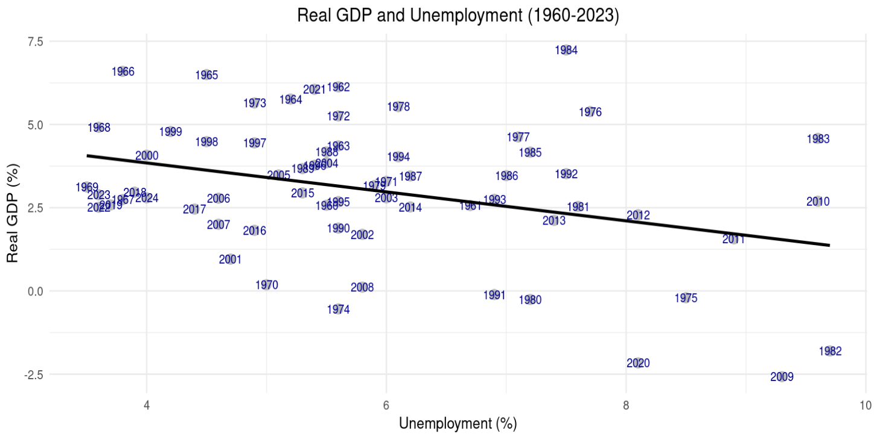

**References:**

World Bank, Inflation, consumer prices for the United States [FPCPITOTLZGUSA], retrieved from FRED, Federal Reserve Bank of St. Louis; https://fred.stlouisfed.org/series/FPCPITOTLZGUSA, August 14, 2025.

U.S. Bureau of Economic Analysis, Real Gross Domestic Product [GDPC1], retrieved from FRED, Federal Reserve Bank of St. Louis; https://fred.stlouisfed.org/series/GDPC1, August 14, 2025.

Federal Reserve Bank of St. Louis, Velocity of M2 Money Stock [M2V], retrieved from FRED, Federal Reserve Bank of St. Louis; https://fred.stlouisfed.org/series/M2V, August 14, 2025.

U.S. Bureau of Labor Statistics, Unemployment Rate [UNRATE], retrieved from FRED, Federal Reserve Bank of St. Louis; https://fred.stlouisfed.org/series/UNRATE, August 14, 2025.